**BuzzStation**

User Guide

# Keypad

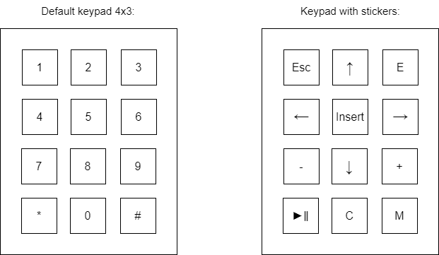

[←], [↑], [→], [↓] - Direction keys

[▶‖] - Play/Pause key

[Esc] - Escape key

[Insert] - Insert / Accept key

[-], [+] - Value change keys

[C] - Clear key

[M] - Menu key

[E] - Edit key

# Playlist

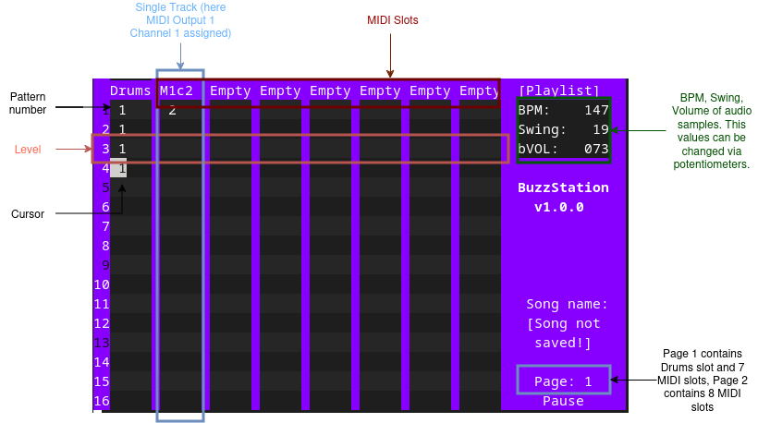

Playlist’s Text-User Interface

The playlist allows you to add patterns in a sequence. Every level, the patterns in the same level are played simultaneously. When playing a song from the picture above, it will play pattern 1 of audio file samples (track one) and pattern 2 of MIDI output 1 channel 1 (track 2) at the same time. Then it will play pattern 1 of track one 3 times in a row.

**MIDI Slots:**

When the cursor is selecting MIDI Slot, press Edit [E] key to add/edit MIDI slot. (Possible options for editing are discussed further in the text.) There’s 16 slots (and 16 tracks), divided into two pages.

Note: *You cannot change or edit track 1 (marked as Drums and Samples, abbreviated to Drums).*

**Pages:**

There’s two pages, 8 tracks per page. To move to the next page, when you are on track 8, just push [→] button. However, your cursor must be at the Drums / MIDI Slots level.

**Moving the cursor:**

Use the directions key to change the cursor position.

**Editing Playlist**:

To add pattern, move your cursor in place, then you can press [+] to add pattern 1, then to change pattern number use [-] or [+]. Last added pattern for the track is remembered, so if your last added pattern number was 10, when you press the [insert] key in another place in the track, pattern 10 will be added there as well.

To remove pattern, press [insert] on pattern. When key [C] is pressed, all patterns on the selected track by cursor are cleared (but not the content of the patterns). Patterns with the same number in different tracks are not identical, that means, you can make a different pattern 1 for MIDI output 1 channel 1 and for MIDI output 1 channel 2.

Note: *You cannot edit the playlist of a track named as ‘Empty’, you need to assign MIDI output and channel to that track first. Move cursor to any assigned (not Empty) midi slot, then, move cursor to next Empty slot on the right.*

**Edit Pattern:**

If you move the cursor to pattern number, and then you press [E] button, you will enter Tracker Mode when your cursor is on the first track, or Piano Roll Mode, when your cursor is on track other than first. Tracker Mode and Piano Roll Mode are discussed later in the text.

**Playing Song:**

When the [▶‖] button is pressed, the song will be played from the level at which the cursor is at (in the screenshot from level 4). If [Esc] key is pressed first and then [▶‖] key, playback will start from the very beginning of the song, regardless of where the cursor is. To play a single pattern, you have to enter the tracker or playlist mode.

**Menu:**

To enter the menu, press the [M] button. Menu is described in next section.

# Playlist Menu

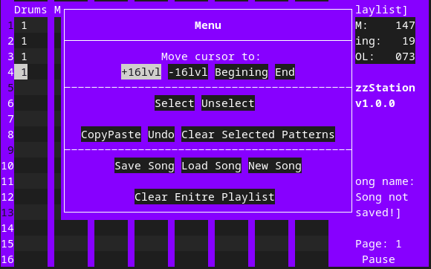Playlist’s Text-User Interface

The menu is divided into 3 segments:

* cursor level change
* operations with selection
* larger operations on song data.

Using the menu, the cursor can be ‘jumped’ to further levels, +16lvl, -16lvl, to begining and end of playlist.

Selecting: When the cursor is at the point where the pattern range is to be selected, select ‘select’ in the menu. Then change the cursor position to where you want the selection to go and select ‘select’ again. Patterns selected in this way can be deleted or copied to another location.

If you make a mistake, you can undo the operation with ‘undo’, but the undo only keeps the previous version from before the operation.

Note: *undo does not keep history, only the previous operation can be undone and only the one which is in the same menu segment as the undo. If an operation is undoable, a warning window will be displayed in which the selection must be confirmed.*

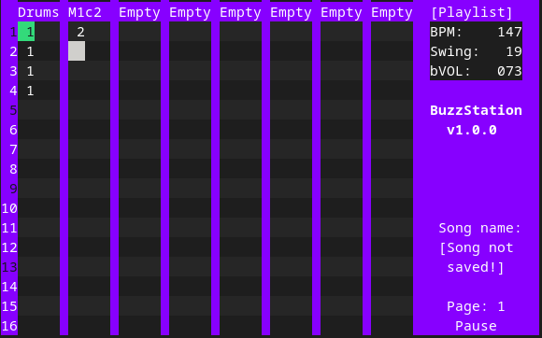

‘Selection’ was choosen in menu, when cursor was on drums track, lvl 1.

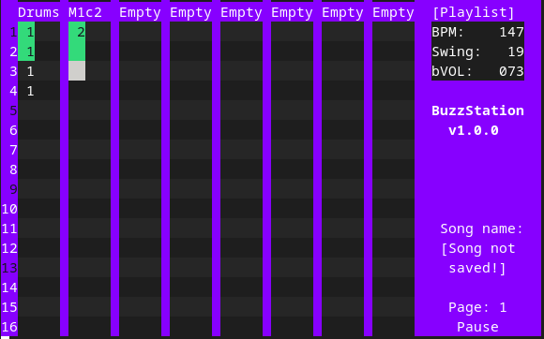‘Selection’ was choosen again in menu, when cursor was on M1c2 track, lvl 2.

# Midi Output Menu

# 

MIDI Menu Text-User Interface

In the MIDI menu, you can assign MIDI output (3 available) and MIDI channel, as well as change parameters of effects like Reverb or Delay, change parameters of filter, envelope or select midi instrument. Changing the output and channel can be made in this menu, by selecting the value with the cursor and changing it with the keys: [-] and [+].

To change other parameters, such as chorus, select the desired parameter with the cursor, press [insert]t] and then the corresponding submenu will open.

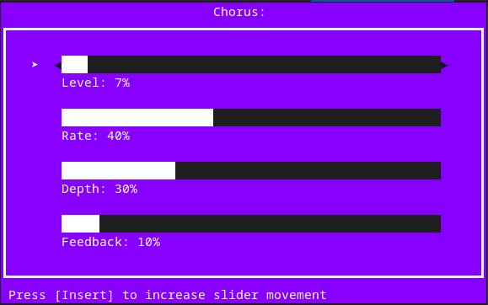

Chorus submenu with sliders

# Audio Sample Tracker

# Tracker Text-User Interface

Tracker allows you to create patterns from audio samples and can act as a drum machine. The tracker has a fixed length of 16 quarter notes. There are 16 tracks so you can load 16 different audio samples. All patterns share the same samples, so it is not possible to define different samples for other patterns in the same project.

**Sample assignation to the track:**

To assign a sample to a track, position the cursor on the desired sample slot, press [insert] and select the sample and confirm choice with [insert].

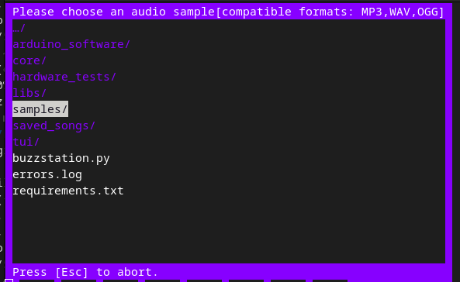

File Browser for selecting audio files

**Note Volume:**

The volume of a note is set in hexadecimal numbers.

**Main volume of sample:**

The master volume determines what the maximum volume of the audio sample is.To change the main sample volume, select the sample on the sample slot with a cursor and use [-] and [+].

**Adding note:**

To add a note, select a place with the cursor, and press [+], then the default note C5 with the highest volume F will be added. To change the pitch of a note, select it and change it with [-] or [+]. To change the volume, select the volume level and use [-] and [+] to change the volume level. Pressing the [insert] key in an empty place adds the last note added and its volume (if the last note added is A#4 vol 5, an insert in another place will add its own note).

**Removing note:**

To remove a note, select it with a cursor and press [insert].

**Menu:**

To enter the menu, press [M] button, then select the required option with direction keys, and confirm choice with [insert]. To quit menu, press [Esc]

**Clearing:**

To clear a single track, press [c], it will clear all notes and corresponding volumes level from that track. This does not affect the sample, so it will remain as was assigned. To clear all of the pattern tracks, enter the menu with [M] key and select ‘Clear’.

**Playing:**

Playing mode can be toggled between Pattern mode ([P] on display) and Song mode ([S] on display) with [Esc] key. In pattern mode, the selected pattern will be looped and playing solo. In song mode, song will be played from the level, where the pattern is on song playlist to end of the song, with all of the midi instruments patterns. To play/pause use [▶‖] key.

**Page:**

There are two pages that contain 8 tracks each, so a total of 16 samples allowed.

# MIDI Piano Roll

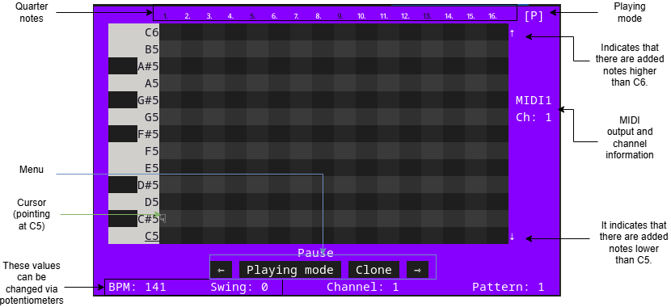Piano Roll Text-User Interface

**Toggling between octaves:**

Notes are available from C1 to C8, but the screen can only display one octave. Use the [up] and [down] keys to dynamically select the desired octave.

**Adding note:**

To add a note, select a place with the cursor, and press [insert].

**Removing note:**

To remove a note, select it with a cursor and press [insert].

**Menu:**

To enter the menu, press [M] button, then select the required option with direction keys, and confirm choice with [insert]. To quit the menu, press [Esc]. Patterns can be toggled in the menu, the pattern can be cloned, which creates an exact copy of the pattern and changes the playing mode.

**Playing:**

Playing mode can be toggled between Pattern mode ([P] on display) and Song mode ([S] on display) in the menu.. In pattern mode, the selected pattern will be looped and playing solo. In song mode, song will be played from the level, where the pattern is on song playlist to end of the song, with drum machine and rest of the midi instruments patterns. To play/pause use [▶‖] key.

**Changing the volume value of a note:**

Move the cursor to the desired note and press [-] and [+]. There’s 8 volume values, but the lowest value it’s not correspond to mute.

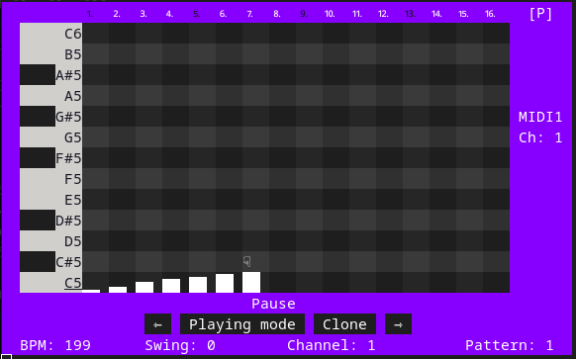

Graphic representation of notes volume values from lowest to highest.

**Clearing:**

To clear an entire pattern, press [c].

**Changing the length value of a note:**

Move the cursor to the desired note and press [E]. Then the cursor will change its appearance. To decrease or increase the length of a note, press [-] or [+]. To abort/accept, quit [Esc] key.

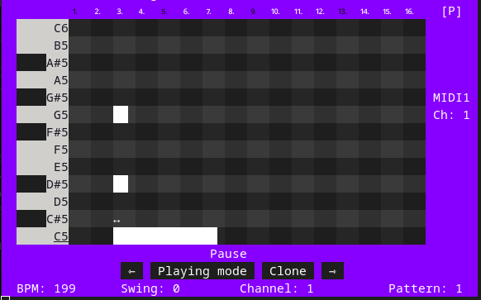

Changing C5 note length.